Glazed Brown Sugar Meatloaf
Prep time 15 min Cook time 1 hr
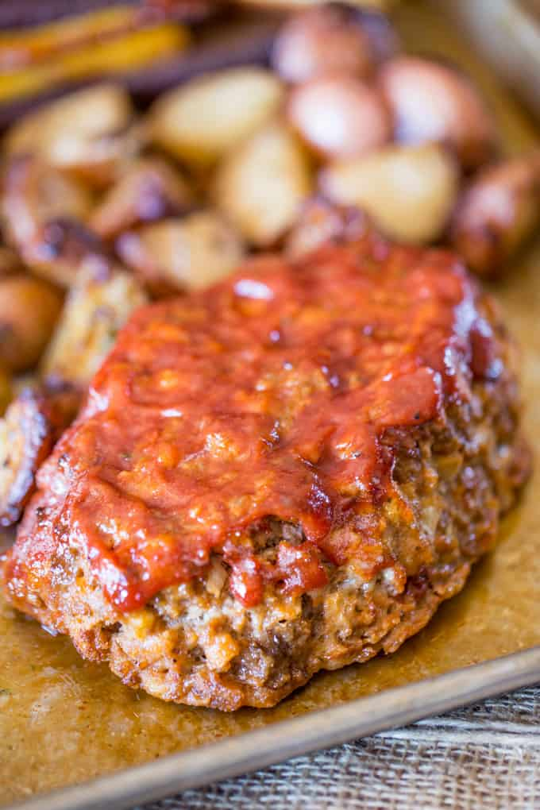
6 Servings
Ingredients
2 slices sandwich bread
1½ lbs ground beef
½ cup milk
1 large egg
½ tsp kosher salt
¼ tsp ground black pepper
1 small yellow onion, finely chopped
¼ tsp ground ginger
¾ cup finely crushed saltine cracker crumbs
¼ cup packed brown sugar
1 tsp Worcestershire sauce
½ cup ketchup
Directions
- Preheat oven to 350 degrees.
- Lay the two pieces of sandwich bread in the pan. (This is to soak up the fat, not for consuming.)
- In a large bowl, mix the beef, milk, egg, salt, pepper, onion, ginger and saltines.
- Shape the mixture into a loaf on top of the bread. Bake for 45 minutes (34 minutes convection oven).
- While the meatloaf is cooking add the brown sugar, ketchup and Worcestershire sauce in a small bowl and mix.
- Glaze the meatloaf and cook a final 15 minutes (11 minutes convection oven).
- Let the meat rest for 10 minutes before slicing.

